
LESSON NOTE | DETAILED EXPLANATORY NOTES
HEALTH AND MEDICAL BIOLOGY
HOMEOSTASIS ( CONCEPT & MECHANISMS )

GRADE 12 - BIOLOGY
■ ■ ■

What is Health and Medical Biology?
Health and medical biology is the field of biology concerned with medicine, healthcare and diagnostics. An individual functions normally when their homeostatic mechanisms are fully working to maintain a constant internal environment. When disease processes disrupt these mechanisms, illness results, and people seek medical care for management and treatment.
The foundation of this whole field is homeostasis - the body's ability to keep its internal conditions stable. Understanding it explains how the body stays well, why disease occurs, and how health workers measure and restore balance in patients.
Areas of Health and Medical Biology
- Homeostasis - the parameters and mechanisms that keep the internal environment stable.
- Disruption of homeostasis - how disease processes upset this balance (e.g. diabetes).
- Systemic response to disease or injury - how the body reacts to harm.
- Diagnostics and treatment - measuring body parameters and managing illness.
Homeostasis (Concept & Mechanisms)
Key Learning Outcomes
By the end of this lesson, students should be able to:
- Define homeostasis and explain why a stable internal environment is essential for life.
- Identify the three components of every homeostatic control system - sensor (receptor), integrating (control) centre and effector.
- Describe negative feedback and explain how it holds a parameter around its set point.
- Describe positive feedback and distinguish it from negative feedback.
- Use thermoregulation and blood glucose as worked examples of homeostatic control.
- Outline the main homeostatic parameters, their clinical significance, and how they are measured.
The Concept of Homeostasis
What is Homeostasis?
Homeostasis refers to the body's ability to regulate its internal environment to maintain stability in response to fluctuations in external or internal conditions. The cells of the body are bathed in tissue fluid, which must be kept within strict limits for them to function. Homeostasis does not mean conditions are perfectly constant; instead, each factor is held within a narrow range around an ideal value called the set point.
Homeostasis can be influenced by intrinsic factors (internal conditions) or extrinsic factors (external, environmental conditions). Several organs work together to maintain it:
- The liver - metabolises toxic substances and, with signals from the pancreas, regulates carbohydrate and lipid metabolism; it is also the main site of cholesterol production.
- The kidneys - regulate blood water levels, reabsorb useful substances, maintain salt and ion balance, regulate blood pH, and excrete urea and other wastes.
- The pancreas - releases the hormones insulin and glucagon that control blood glucose.
- The brain (hypothalamus) - regulates body temperature, heart rate, blood pressure and circadian (sleep–wake) rhythms, working through the autonomic nervous system and the endocrine system.
Homeostasis - Terminologies and Concepts
Understanding homeostasis requires familiarity with several key terms:
- Internal environment: the tissue fluid that surrounds and bathes the body's cells.
- Set point: the ideal value (or normal range) at which a parameter is maintained.
- Sensor/receptor: a structure that detects a change in the internal or external environment - for example, peripheral chemoreceptors detect changes in blood pH.
- Integrating (control) centre: receives information from the sensors and initiates the response - the most important example is the hypothalamus.
- Effector: an organ or tissue that acts to bring about the change needed to restore homeostasis - for example, the kidney retaining water when blood pressure is low.
- Negative feedback: a response that reverses a change, returning a parameter to its set point.
- Positive feedback: a response that amplifies a change, pushing a parameter further from normal.
The Components of a Homeostatic Control System
All homeostatic control mechanisms have at least three interdependent components for the variable being regulated. A sensor (receptor) detects the change; the integrating (control) centre receives this information and decides on a response; and an effector carries out the action that corrects the change. The corrected condition is then detected again, forming a continuous loop. Positive and negative feedback are the mechanisms that link these three components together.
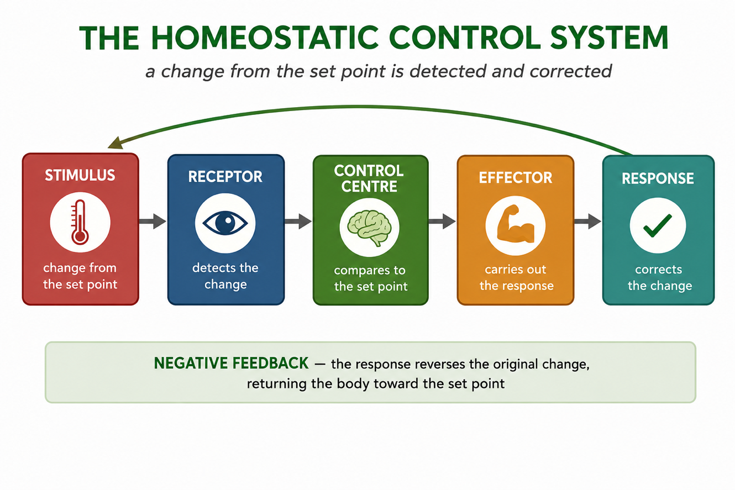
Figure 1: The homeostatic control system - a change is detected by a receptor, processed by the control centre, and corrected by an effector.
Negative Feedback
Negative feedback mechanisms use one of the products of a process to reduce the output of that process, returning the organ or system to its normal range. Most homeostatic processes use negative feedback to hold a parameter around its set point. Because the response opposes the original change, the factor oscillates gently around the set point rather than drifting away. Negative feedback controls temperature, blood glucose, blood pH and water balance.
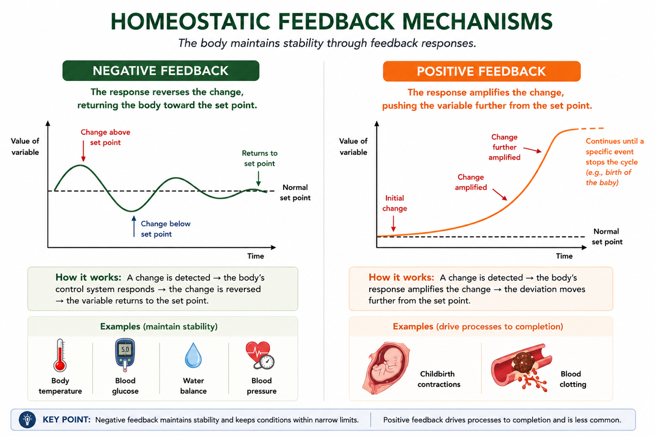
Figure 2: Negative feedback reverses changes and restores the set point, whereas positive feedback amplifies changes until a process is completed.
Thermoregulation - Controlling Core Temperature
Temperature control is the classic example of negative feedback. Humans are endothermic (warm-blooded), maintaining a core temperature near 37 °C; heat is mainly produced by the liver and by muscle contractions. Nerve cells (sensors) relay information about body temperature to the hypothalamus (the integrating centre), which signals several effectors:
- If the body is too hot: sweat glands release sweat (cooling by evaporation) and blood vessels widen (vasodilation) to give off more heat. Some animals also pant, cooling by evaporation from the mouth and throat.
- If the body is too cold: the muscles shiver to generate heat (shivering thermogenesis) and blood vessels narrow (vasoconstriction) to retain heat; a counter-current exchange in the limbs returns heat to the body core.
Once the core temperature returns to normal, the sensors send messages that switch the responses off. The set point itself can change with circumstances - for example, the hypothalamus raises it during a fever to help fight infection. If control fails, hyperthermia can occur (around 45 °C cellular proteins denature and metabolism stops), or hypothermia (core temperature below about 35 °C, causing shivering then confusion).
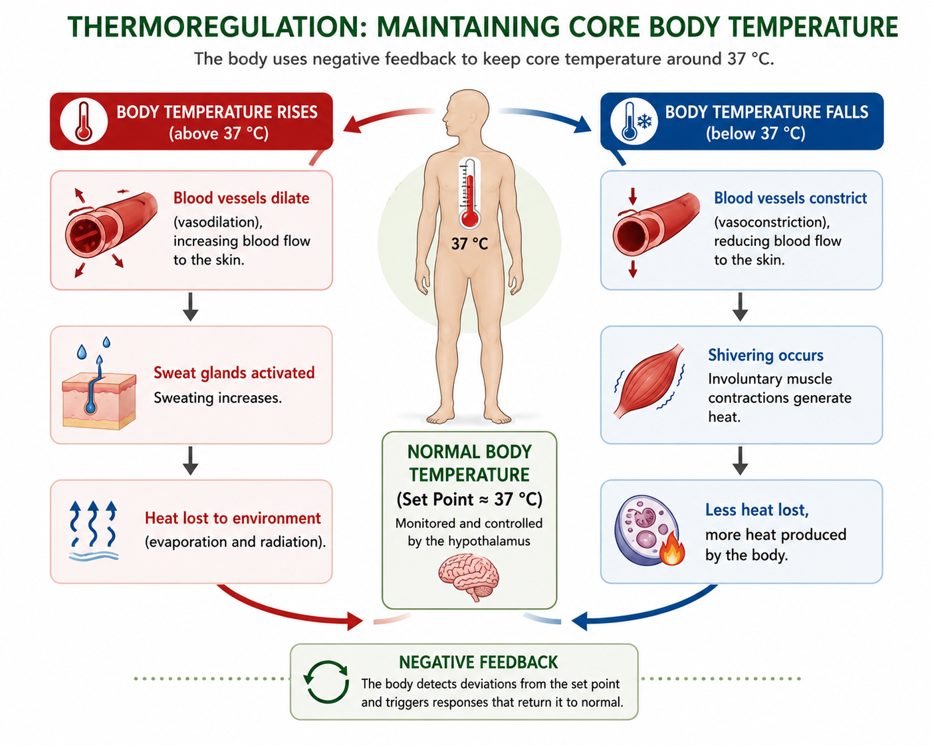
Figure 3: Thermoregulation by negative feedback: opposite physiological responses to overheating and cooling restore core body temperature to the normal set point (approximately 37 °C).
Positive Feedback
In positive feedback, an activated component enhances or further upregulates the process that produced it, creating an ever-stronger response. Positive feedback is designed to push a parameter out of its normal range, so it is used less often in homeostasis. A key example is the blood-clotting cascade: damage to a blood vessel activates clotting proteins (zymogens), and each activated factor cleaves and activates the next - Factor X → thrombin → fibrin - building a stable clot. Thrombin also activates more Factor X, amplifying the cascade until the wound is sealed. Another example is the contractions of childbirth, which intensify until delivery. Positive feedback is normally short-lived and stops once its goal is reached.
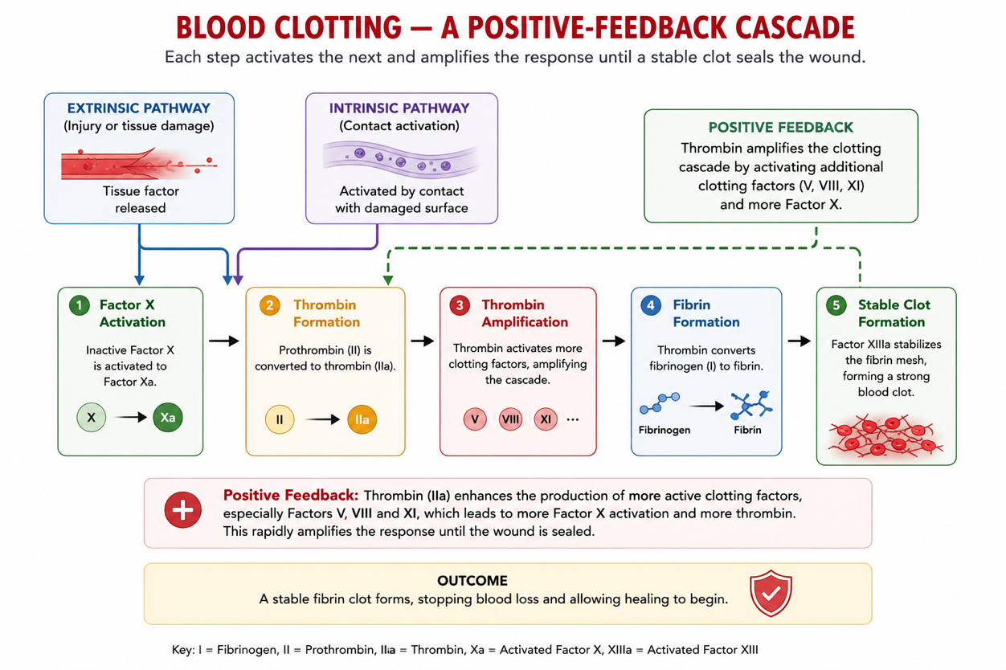
Figure 4: Positive feedback in blood clotting: activation of the clotting cascade amplifies thrombin production, leading to fibrin formation and a stable blood clot.
Blood Glucose Regulation
Blood glucose is an important homeostatic parameter controlled by negative feedback. The primary sensors are the beta cells of the pancreatic islets. When blood glucose is high (after a meal), the beta cells release insulin (and inhibit the alpha cells), so the liver, fat and muscle cells take up glucose and the liver stores it as glycogen - the level falls. When blood glucose is low, the pancreatic alpha cells release glucagon, which makes the liver break glycogen down and release glucose - the level rises. Faulty glucagon action causes hypoglycaemia (glucose too low); faulty insulin action causes hyperglycaemia (glucose too high), which, if prolonged, leads to diabetes.
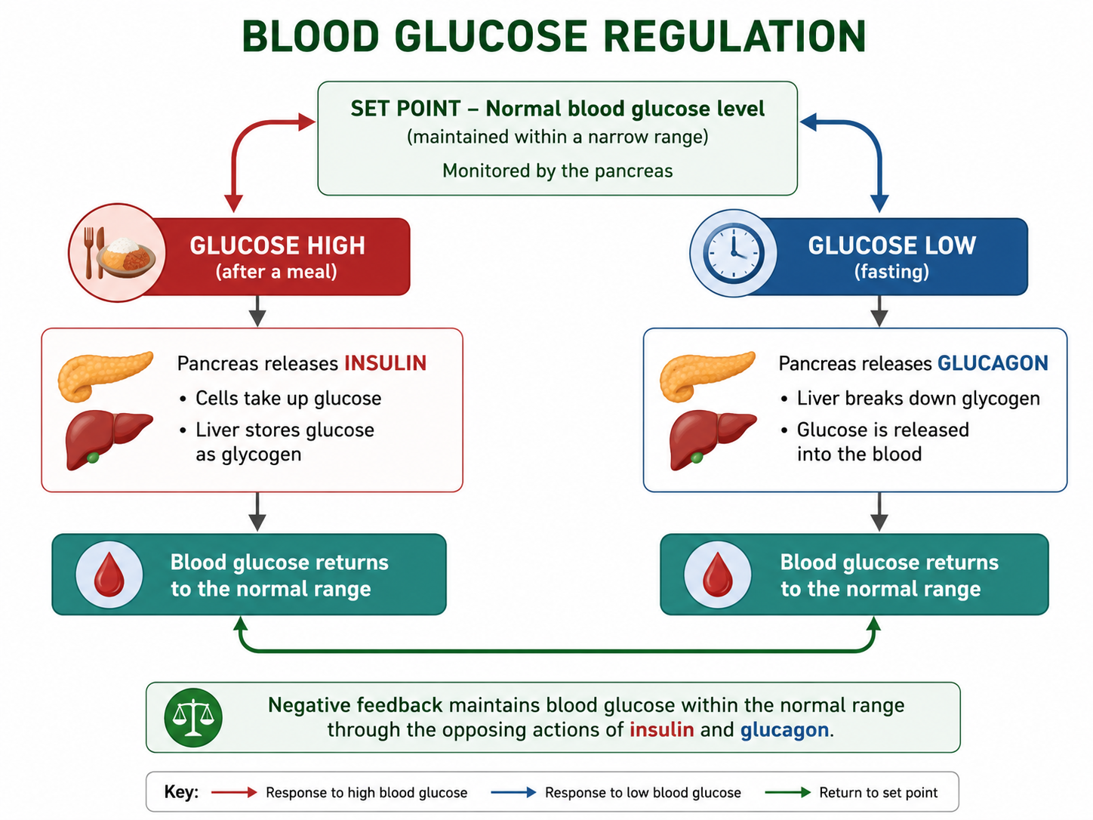
Figure 5: Blood glucose regulation - insulin lowers glucose, glucagon raises it (negative feedback).
Other Homeostatic Parameters
Besides temperature and glucose, the body holds many other parameters within a narrow homeostatic window. Each has a clinical significance - health workers measure them to assess a patient's health. The sections that follow look at the main ones in turn.
Parameter | Regulated by | Clinical significance
Core temperature | Hypothalamus, skin, muscles | Fever or hypothermia signals infection or exposure
Blood glucose | Insulin and glucagon (pancreas) | Diagnosing and managing diabetes
Blood gases & pH | Respiratory centre; chemoreceptors | Breathing, oxygen delivery, acidosis / alkalosis
Arterial blood pressure | Heart, vessels, kidneys; baroreceptors | Detecting hypertension and circulatory disease
Water, Na⁺, K⁺, Ca²⁺ | Kidneys and hormones (ADH, aldosterone) | Fluid balance; nerve and muscle function
Iron and copper | Hepcidin/ferroportin; gut absorption | Anaemia (iron); trace-element deficiency or excess
Regulation of Blood Gases and Blood pH
Oxygen, carbon dioxide and blood pH are kept stable by the respiratory centre in the medulla. Peripheral chemoreceptors in the carotid arteries and aortic arch, and central chemoreceptors in the medulla, detect a rise in CO₂ or a fall in pH. The respiratory centre then increases the breathing rate, removing more CO₂ and restoring pH - a negative-feedback loop. When CO₂ is low, breathing slows.
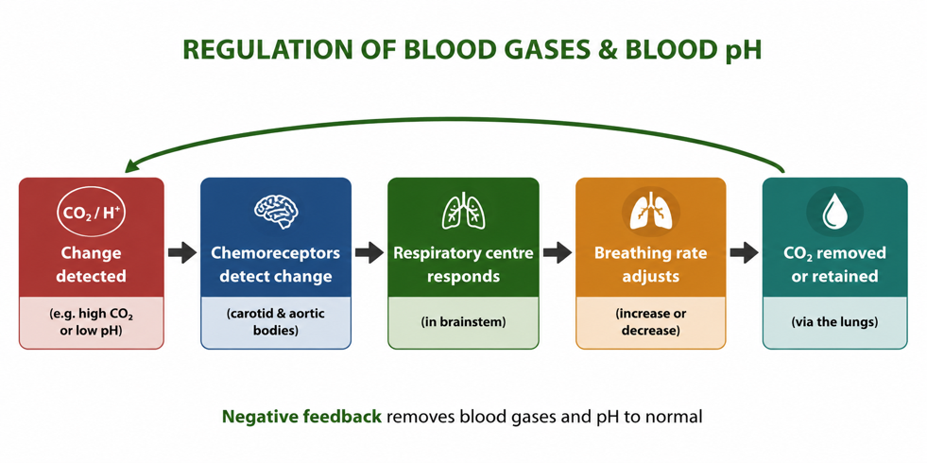
Figure 6: Regulation of blood gases and pH - chemoreceptors signal the respiratory centre to adjust breathing.
Arterial Blood Pressure
Blood pressure must stay within a safe range. Baroreceptors (pressure receptors) in the carotid arteries and aorta detect changes and signal the cardiovascular centre in the medulla. If pressure rises, blood vessels dilate and the heart slows, lowering pressure; if it falls, vessels constrict and the heart speeds up (and adrenaline may be released). This negative feedback keeps blood flowing steadily to the organs.
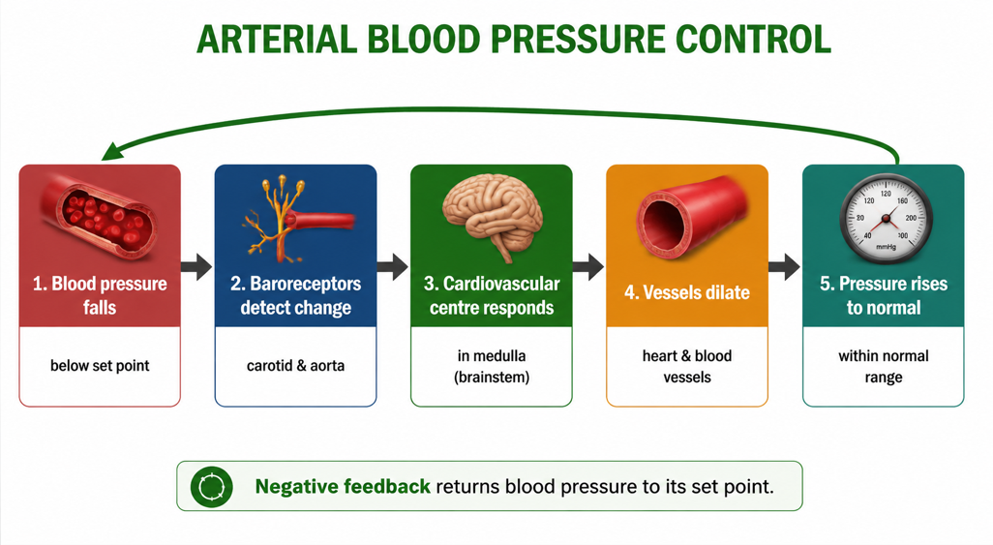
Figure 7: Arterial blood pressure control - baroreceptors trigger changes that return pressure to its set point.
Osmoregulation and Fluid Balance
Osmoregulation is the control of the body's water and salt balance, carried out mainly by the kidneys. When the blood is too concentrated, the hypothalamus triggers the release of antidiuretic hormone (ADH), which makes the kidneys reabsorb more water, producing concentrated urine; when the blood is too dilute, less ADH is released. The hormone aldosterone similarly controls sodium reabsorption. Together they keep water, blood pressure and ion levels (Na⁺, K⁺) stable.
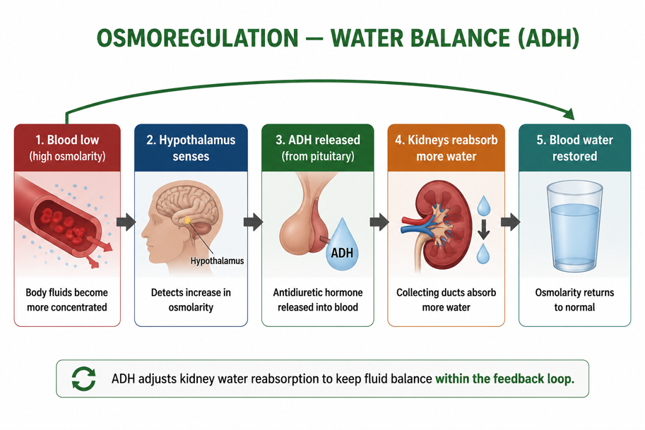
Figure 8: Osmoregulation - ADH adjusts how much water the kidneys reabsorb to keep fluid balance.
Iron Homeostasis
Iron is essential because it forms part of haemoglobin, which carries oxygen in red blood cells - iron deficiency is the most common cause of anaemia. When body iron is low, the hormone hepcidin decreases, which opens the ferroportin channels in the gut lining so more iron is absorbed from food; when iron is high, hepcidin rises and absorption falls. This keeps iron within safe limits, since too much is toxic.
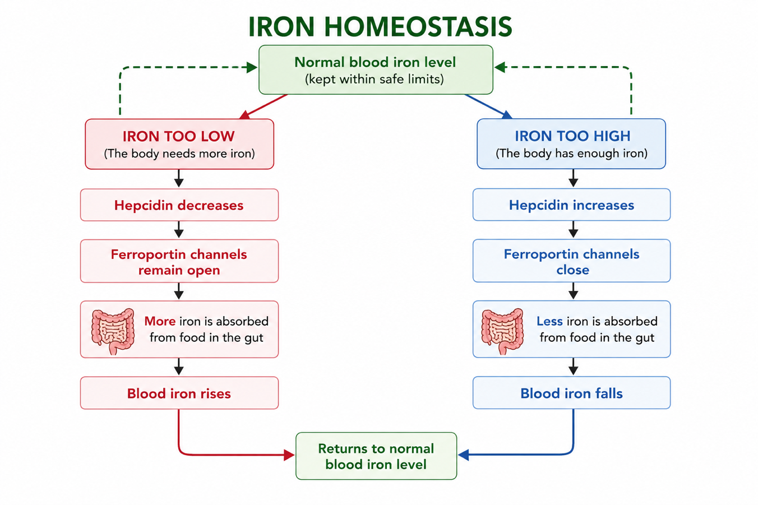
Figure 9: Iron homeostasis - the hormone hepcidin adjusts iron absorption through ferroportin channels.
Copper Balance
Copper is an essential trace element needed for many enzymes and for the proper functioning of organs. The body keeps a steady supply by controlling how much copper is absorbed in the gut, distributing it to organs, and excreting any excess through bile and urine. As with all nutrients, both too little and too much copper cause health problems, so absorption and excretion are balanced.
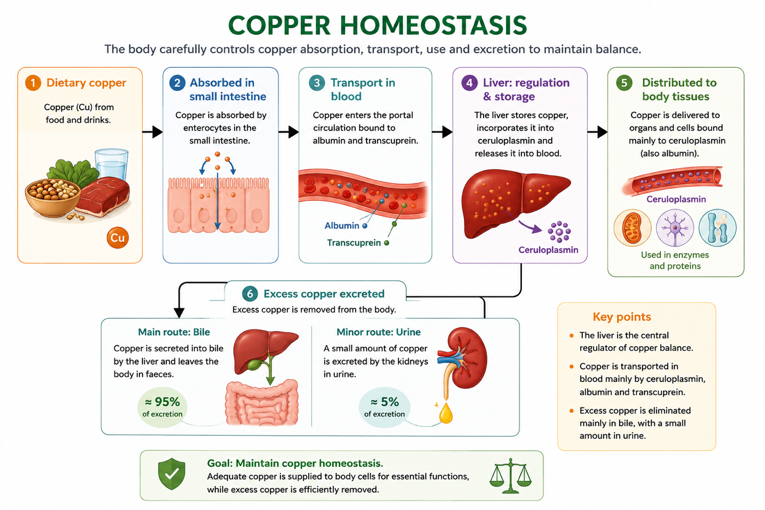
Figure 10: Copper balance - the body controls absorption and excretion to keep a steady supply.
Worked Example - A Negative Feedback Loop (Temperature)
Situation: a student exercises on a hot day and core body temperature rises above 37 °C.
- Stimulus: core temperature rises above the set point.
- Sensor: nerve cells (thermoreceptors) detect the rise.
- Integrating centre: the hypothalamus compares the temperature with the 37 °C set point.
- Effectors & response: sweat glands produce sweat and blood vessels undergo vasodilation, releasing heat.
- Result: core temperature falls back toward 37 °C; the sensors then switch the responses off.
This is negative feedback: the response (cooling) reverses the original change (overheating). The same logic applies to blood glucose, pH and water balance - only the sensor, centre and effectors differ.
When Homeostasis Fails: Disease
Disease often results when a homeostatic mechanism breaks down. Diabetes mellitus is a failure of blood-glucose control: in type 1 the pancreas cannot make enough insulin, and in type 2 the cells stop responding to it, so blood glucose stays dangerously high (hyperglycaemia). Failures of temperature control cause hyperthermia or hypothermia, and very low glucose (hypoglycaemia) can lead to coma. Because these conditions show up as abnormal readings, measuring homeostatic parameters is central to diagnosis and treatment.
Why Homeostasis Matters
- Survival - cells and enzymes only work within narrow limits, and homeostasis keeps them there.
- Health and disease - most illnesses involve a breakdown of homeostatic control.
- Medicine - measuring temperature, glucose and blood pressure is the basis of diagnosis.
- Whole-body coordination - it shows how the nervous and endocrine systems and the organs work together.
PNG Context Example
Understanding homeostasis has practical applications across Papua New Guinea. A nurse taking a patient's temperature, checking blood glucose with a glucometer, or measuring blood pressure is assessing homeostatic parameters. The same knowledge guides the management of diabetes, dehydration (a real risk in hot, active conditions), fever in malaria, and fluid balance in clinics and aid posts - linking school biology directly to community health and wellbeing.
References & Related Documents
Source Documents
- STEM Biology Student Resource Book - Grade 12, Term 1. Module 12.1 Health and Medical Biology, Topic 1: Homeostasis (Concept of Homeostasis; Negative & Positive Feedback; Temperature; Blood Glucose; Homeostatic Parameters). Department of Education, PNG (2021).
- STEM Biology Syllabus - Grade 12, Term 1. Topic 1: Homeostasis; Performance Indicators 12.1.1a–12.1.1c.
- Biology Standards-Based Syllabus, Grades 11 & 12 (PNG SBC 2020) - Strand 2: Life; Grade 12 evidence outcome: “Investigate how homeostatic balance occurs in cells and organisms.”
Further Reading & References
- OpenStax Anatomy & Physiology - Homeostasis. https://openstax.org/books/anatomy-and-physiology
- Khan Academy - Homeostasis and feedback loops. https://www.khanacademy.org/science/biology

